PROJECT DOCUMENT
YouTube Video Repurposing Agent
Project Question: Fetch video transcripts from a YouTube URL and draft formatted social posts (X thread, LinkedIn, newsletter) to Google Docs.

1. Goal of the Project
The goal of this project is to automate the process of converting a YouTube video into useful social media content. Instead of manually watching a video, reading its transcript, and creating separate posts for different platforms, the workflow collects the video information, processes it with AI, generates formatted content, and stores the final result in Google Docs.

2. Objectives of the Project
- Accept a YouTube video URL from the user through Telegram.
- Prepare and organize the received URL and required data.
- Fetch the video transcript or required video information using an external API/service.
- Use an AI Agent to understand the transcript and identify important points.
- Generate an X thread, LinkedIn post, and newsletter from the same video content.
- Create and update a Google Document with the generated content.
- Send a confirmation message to the user through Telegram after completion.

3. Requirements of the Project
n8n: Used to build and automate the complete workflow.
Telegram: Used to receive the YouTube URL and send the final confirmation.
YouTube transcript service/API: Used through the HTTP Request node to obtain transcript/video information.
Groq Chat Model: Provides the language model used by the AI Agent.
AI Agent: Processes the transcript and generates the required content formats.
Google Docs: Used to create and store the generated content.
Internet connection: Required for Telegram, external API, Groq, and Google services.

Whole Project Block Diagram
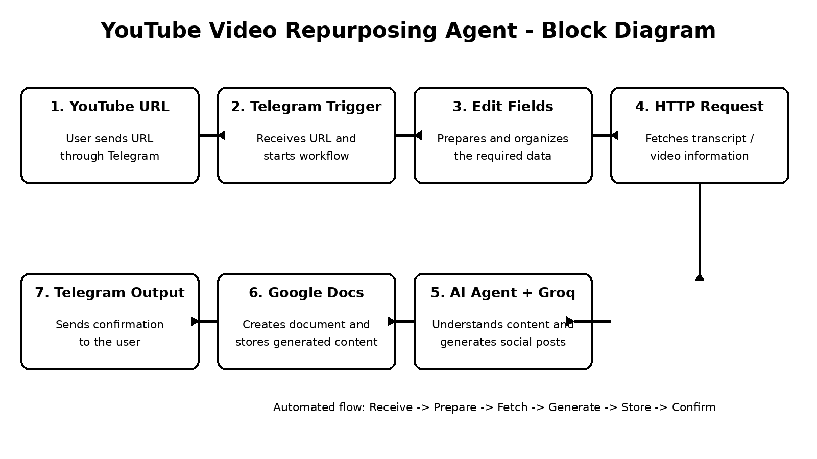

4. What We Did in the Project
1. Telegram Trigger - Receives the YouTube URL sent by the user and starts the workflow.
2. Edit Fields - Prepares and organizes the URL and other required data.
3. HTTP Request - Communicates with the external transcript/video service and fetches the required information.
4. AI Agent - Processes the received content and generates the required social media content.
5. Groq Chat Model - Acts as the language model connected to the AI Agent and helps understand and generate text.
6. Create a Document - Creates a Google Document for the generated content.
7. Update a Document - Adds the generated X thread, LinkedIn post, and newsletter to the document.
8. Send a Text Message - Sends a completion/confirmation message back to the user through Telegram.
Final Workflow Used in the Project:
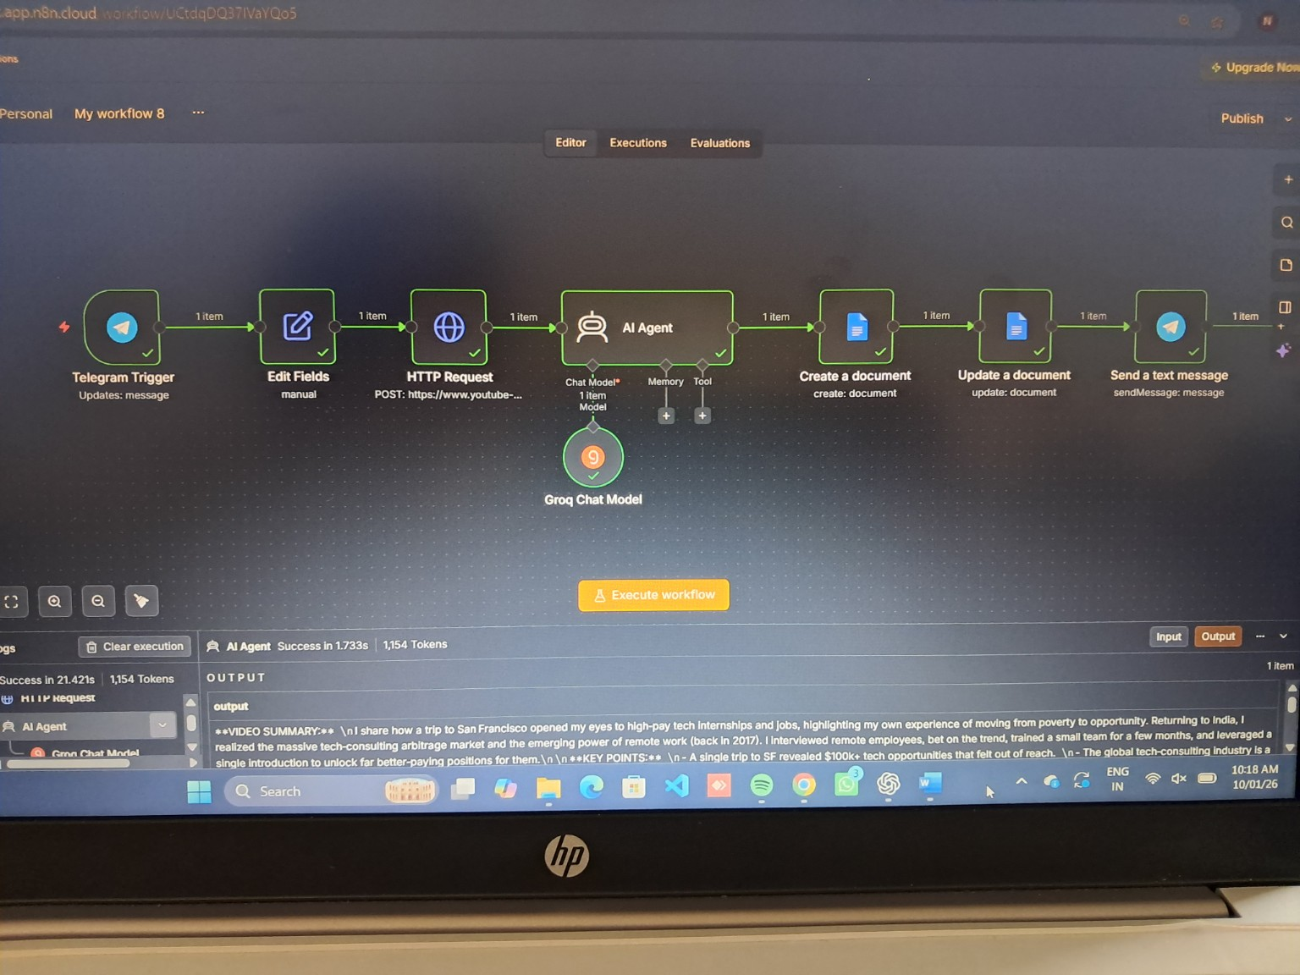
Final successfully executed n8n workflow.
Overall flow: YouTube URL -> Telegram Trigger -> Edit Fields -> HTTP Request -> AI Agent + Groq Chat Model -> Create Document -> Update Document -> Telegram confirmation.

5. Output and Conclusion of the Project

Output
The project was successfully executed. A YouTube URL can be provided through Telegram, the workflow processes the video information, and the AI Agent generates formatted content for an X thread, LinkedIn post, and newsletter. The generated content is stored in a Google Document, and a confirmation message is sent to the user.

Conclusion
The YouTube Video Repurposing Agent demonstrates how n8n automation and AI can reduce manual content-creation work. One YouTube video can be converted into multiple useful content formats through a single automated workflow. The project combines Telegram, an external transcript/API service, an AI Agent with the Groq Chat Model, and Google Docs to provide an end-to-end content repurposing solution.

Quick Project Summary
Stage | Purpose
Input | Receive YouTube URL through Telegram
Data | Fetch transcript/video information
AI | Understand content and generate posts
Storage | Save content in Google Docs
Output | Send confirmation to the user

